# Getting started with Strokes

***Disclaimer: The current version of Strokes is still in alpha stage. Using this software is at your own risk.***

## Installation

To get started, make sure you closed all instances of Visual Studio 2010

* Download the latest stable version from <https://github.com/jonasswiatek/strokes/downloads>
* Run the downloaded .vsix file by double clicking it.
* A Visual Studio Extension Installer shows up. Make sure you select the correct version on which to install Strokes (only compatible with Visual Studio 2010)

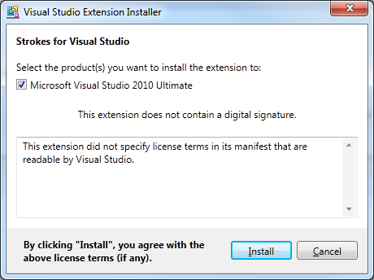

* Click “Install”
* If all went well you should get the following prompt

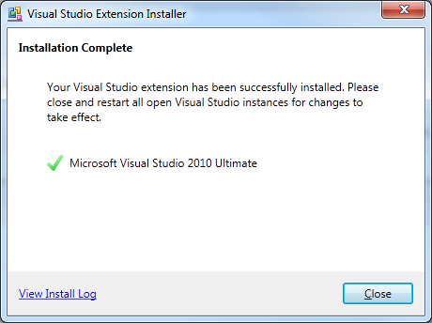

**If something went wrong and you get an installation error. Please click the ‘View Install Log’ and mail the full log that is shown to on of us (see githuh.com/jonasswiatek/strokes for more information)**

## Using Strokes

### Unlocking achievements

To start getting achievements, you need to make sure that you write your code in the Strokes template. In the future we will have the ability to also unlock achievements in other project.

* Start a new project in Visual Studio.
* In the Visual C# templates, select the “Strokes Achievement Project”  
  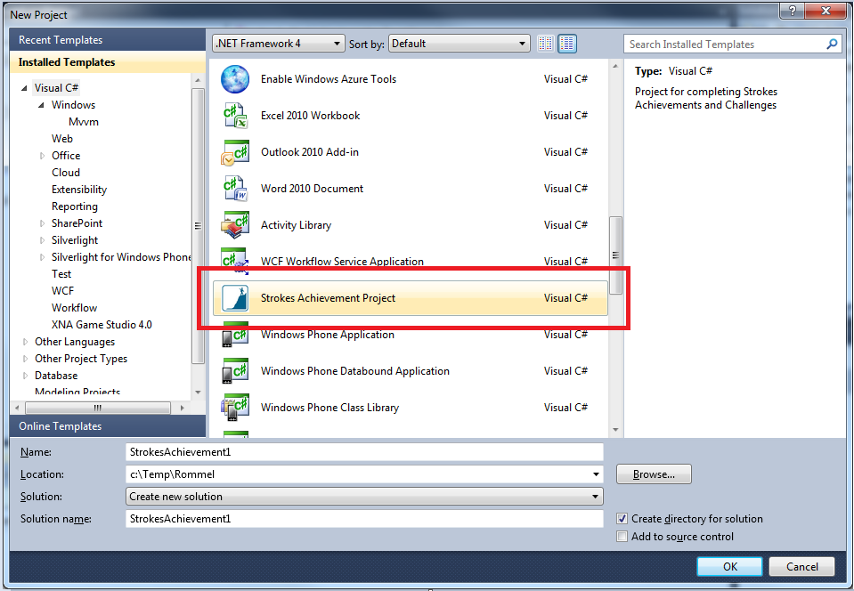
* Create the solution by clicking ok (after filling in the Name, Location and Solution Name fields ofcourse)
* To get achievement using simple Console application do the following.
* RightClick the CalculatorChallenge.Cs file in the Solution Explorer and choose “Delete”

Do not delete this file if you want to unlock the Calculator challenge and instead try to ‘solve’ the challenge by writing the correct code in the 4 methods being shown.

* RightClick the MyFirstAchievement project and choose Add-> Class and name the class “Program”
* Write the following Main method in this new file so that it looks like this:  
  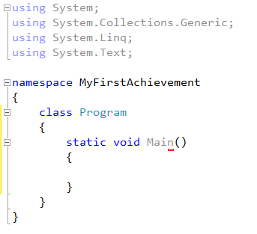
* Now right click the project again the solution explorer and choose “Properties” in the menu
* A properties pane shows up. Change the “Output type” “from Class Library” to “Console Application”  
   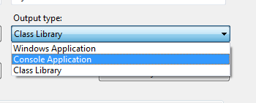
* You are now ready to start getting achievements by simply writing code in the Main method. Evertytime you now Build your current code which contains something achievable a new popup shows up. You can click the “Magnifier glass”-icon to see what code made you unlock the achievement.  
  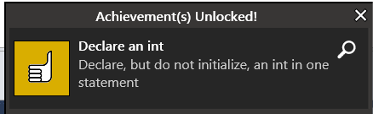

### Viewing your statistic and settings

To show your current progress of unlocked achievement, you can at any time when using Visual Studio 2010 open a full summary of what you’ve achieved so far.

* In the menu, click the Tools menu
* Next choose “C# Achievement”  
  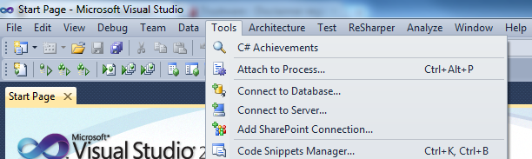
* A new tab will show where you can see , per category, what achievement you have unlocked and which ones you can unlock. Some achievements will need another achievement to be achieved before they can be unlocked. These ‘second tier’ achievement will only show in the list once you have achieved the ‘first tier’ achievement.

For example: The following achievement will only be unlockable once you achieve the “Declare an array” achievement: Declare a multidimensional array, Declare and initialize an array with an ainitializer list, Array length and Jag.



* Clicking each category on the left will show the relevant achievements for that category.
* Clicking on the Settings button will give you three possibilities:
  + Reset achievement progress: this will delete all your unlocked achievement
  + Enable strokes in all projects: this button doesn’t work yet
  + Select language: this button doesn’t work yet